Richard Ziegahn

June-July 2018

[ricky.ziegahn@gmail.com](mailto:ricky.ziegahn@gmail.com)

Oven

# Oven Temperature Control

The oven software is comprised of two parts: The Arduino code and the Python (2.7) code.

## Arduino

### General Overview

The Arduino code is a simple PI controller. The libraries used can be found at: <https://github.com/adafruit/Adafruit-MAX31855-library>

To read the thermocouples, MAX31855 type K amplifiers are used, and a crydom MPDCD3 DC Relay is used to turn the oven on (with a power supply).

The variable ‘channelamount’ defines the number of channels to control (not thermocouples). Modifying this value will change the number of heaters to control. Changing the number of channels will take care of everything except for setting up the thermocouple. To add another thermocouple to be measured, include

Adafruit_MAX31855 <thermocouplename>(CLKPIN, <CSPIN>, DO)

The current name scheme is thermocouple_i(CLK, CS[i], DO), where i is the oven number (beginning from zero). This thermocouple will also need to be added to the read_temperature function with an if statement.

The clock and data out pins are the same for all the thermocouples, the chip select pin (CS) is the only varying pin.

A channel for the sample sensor is also included, independent from the ‘channelamount,’ and left out of the loops and arrays that control the channels.

In the functions, it is setup such that if the temperature is outside of the band, the integral is not increased or decreased (starts at zero), and the oven is totally on (if below the band), or totally off (if above the band). If inside the band, the integral term is increased or decreased, and the output power is determined by the proportional term plus the integral term plus a half. If when summing these, the output is greater than 1 (fully on), the output will be set to 1. If when summing these, the output is less than 0 (fully off), the output will be set to 0.

$$Error=Set Temperature-Measured Temperature$$

$$Proportional Term=\frac{Error}{Band}$$

$$Integral Term=\frac{Error}{Band×Integral Time}$$

$$Output=Proportional Term+Integral Term+0.5$$

A derivative term is left out because it requires much more tuning, and by undershooting, the integral term grows much more because it approaches the target temperature later, resulting in a much longer settling time.

There is a safety flag that can disable the oven if the temperature is unable to be read for a channel. If the flag is raised (setting equal to 1 instead of the default zero), the oven will be disabled.

Inside the loop, the first two lines include setting the oven off, so that if the loop ends to receive new target temperatures, the oven does not remain on high if it hangs. The next for loop accepts the new parameters (target temperature, band, integral time), and resets the integral term to zero.

The control loop is contained in the ‘while (!Serial.available)’ loop. The loop reads the temperature for each channel, and the sample. For each channel (not the sample), it will then calculate the error, and do the rest of the necessary calculations to determine the amount of time the oven must be on per cycle to give the power required. When the time is determined, another loop is entered (‘while (time_1 – time_2 > dt)’), where the time is checked for each channel to see if it has reached the amount of time the oven must be on, if it has, it turns off until the next cycle.

The control loop is can be ended with serial input, so at the end the new parameters can be received if there was serial input during the loop described in the previous paragraph, if there is not, the temperature will continue to be controlled.

### Function overview

read_temperature(channel): Reads the temperature of a given channel. If there is no temperature, a flag will go off which disables the oven until a temperature can be read

wait_for_input(): Stops the arduino from proceeding without receiving all its parameters. Without this, the arduino might not update some parameters and the python code will think it did.

accept_parameters(channel): Accepts the set temperature, band, and integral time for a given channel.

calculate_error(channel): Calculates the error using the formula seen above, for a given channel.

calculate_proportional_term(channel): Calculates the proportional term using the formula seen above, for a given channel.

calculate_integral_term(channel): Calculates the integral term using the formula seen above, for a given channel.

calculate_output(channel): Calculates the output (a value between 0 and 1, representing the fraction of full power needed) using the formula seen above, for a given channel. The function makes sure that the output is at least 0 and at most 1. The function also doesn’t let a wild integral term keep it permanently on or off, if the temperature exits the band, it will be fully on if below and fully off if above.

calculate_up_time(channel): Calculates the fraction of time (dt = 1 second), by multiplying the time between measurements by the output, for a given channel.

give_weights(channel): Writes the value of the proportional term, integral term, and output to the serial, used for logging purposes.

check_time(channel): For a given channel, check if the time the heater has been on has not exceeded the time it is supposed to be on. If it has, turn it off, if it has not, keep it on.

## Python

### General Overview

The Python code passes the parameters to the Arduino, receives the state of the controller, graphs it, creates an interface, and has the option of logging the data to a text file. To log the data, set logging = ‘on’ at line 12. The libraries used are serial, time, and PyQtGraph, which can be found at <http://pyqtgraph.org>.

Like the Arduino code, the python code has a line to include the number of heaters. The line is found on line 17.

PyQtGraph is used for live graphing of the temperature. To initialize a plot, do as follows (in the python code, each of these objects is instead part of a list of objects):

from pyqtgraph.Qt import QtGui

import pyqtgraph as pg

app = QtGui.QApplication([])

p = pg.plot()

curve = p.plot()

To set or update the data and the graph, include

curve.setData(x = <list>, y = <list>)

app.processEvents()

This does not update the range, the range can be updated with one of the following (required before app.processEvents())

p.setXRange(<x1>,<x2>)

p.setYRange(<y1>,<y2>)

p.enableAutoRange()

p.disableAutoRange(x=<True/False>,y=<True/False>)

The range is setup such that if the previous quarter of the terms displayed are within the band, the y axis does not auto scale and instead only shows the band. If at least one of the previous quarter of displayed terms is outside the band, a graph containing all of the last 300 temperatures is shown.

The inputting of temperatures is done through a text file. Each time the program is started, a text file is created with a default target temperature of zero for all channels, which is then written to the Arduino. Each cycle within the loop, the state of the oven is received and printed to the console. If a change in the text file is detected, new parameters (including the new target temperature) will be sent to the Arduino. Anything unchanged will remain the same but will be rewritten to the Arduino.

### Function overview

read_target_temp(channel): For a given channel, reads the temperature from the temperature input text file.

give_target_settings(channel): Checks if the set temperatures are the same as all the inputted temperatures. If it is not, it will give the Arduino a new set of parameters, for all channels.

read_measured_temp(channel): Reads the temperature from the Arduino for a given channel.

read_state(channel): Reads the weights of each term (output, proportional term, integral term), for a given channel.

read_sample_temperature(): Reads the temperature of the sample sensor from the Arduino.

# Oven Construction

## Inner Oven

### Overview

The inner most part of the oven is a bobbin with heater wire wrapped around it using ceramic tubes (Figure 1). The ceramic tubes are FRM-02018-X tubes ([OMEGA](https://omega.ca/pptst_eng/ORX_INSULATORS.html)). There are 22 20 mm tubes and a single 35 mm tube at the end. Each tube has 4 holes. 4 6’’ ceramic tubes will be needed for the inner oven.

There are 2 wires (0.1 mm Kanthal) running in parallel through this loop. The two loops run opposite to each other: one loop attaches them at the bottom and one loop attaches them at the top of the belt (Figure 2). Figure 3 shows a diagram of one of the two wire loops; the other loop would be doing the opposite (flip the image upside down). For this to be possible, on the top loop, the first and last holes must be skipped so that they will lead into the final 35 mm tube.

To install the 35 mm tube, the belt must be looped around, and the wires must be threaded through the tube and the wires must be pulled to get the tube into place. On the 11th ceramic tube, opposite to the 35 mm tube, there is a type K thermocouple around the tube (Figure 4). Behind the tube is a strip of mica, to prevent the thermocouple from making contact with the bobbin.

All of this is to be cemented in, cement is to be added to the sides of the bobbin before installing the ceramic tubes, then more is to be added at the top and bottom of the tubes to ensure that all the wire is surrounded in cement. It is important to make sure that the wire loops make no contact the bobbin, to prevent a short. Tightly wrapping wire around the bobbin when drying is advised to ensure everything stays in place, and expansion will cause the next step to fail.

There are two thermocouples that are placed within the bobbin, they are viewable in figure 1. The top of the bobbin has a circular sheet of beryllium, and two holes for the two thermocouples. The sheet of beryllium is cemented in, and the ceramic tubes that the thermocouples are in simply slide in. It is recommended to insert the thermocouples before bending them into shape. The thermocouples tubes are TRM-010364-X ([OMEGA](https://omega.ca/pptst_eng/ORX_INSULATORS.html)). If creating new thermocouples, it is recommended to use 500V when welding. The thermocouples are also oddly not aligned with the holes in the outer heater that it is inserted into. The distance between the holes (furthest edge of each hole, not measured at the center) on the inner heater is 15.1 mm and the distance between the holes on the outer heater is 24.5 mm. The thermocouple will have to be broken in 2 spots due to this: once where it meets the bobbin and again 4.5 mm from that point. The thermocouple must then be straightened such that it forms roughly a 90-degree angle with the bobbin (or crushing is risked).

A hollow ceramic cylinder is placed around the inner heater before the inner heater is inserted into the outer heater (see Figure 5), and is lightly cemented around the inner bobbin at the top and bottom of the lateral area of ceramic tube. When inserted into the outer heater, the thermocouples must all be straight so that the go directly into the holes in the outer heater; pulling the thermocouples through may result in them being crushed and eventually, the wire breaking. They are extremely fragile. If accessing the inner heater, it is recommended to remove the beryllium sheet and replace the thermocouples so then can be straight, otherwise it is very likely they will end up crushed (and then will have to be replaced anyway).

The resistance of the inner heater is about 15Ω, each loop having a resistance of about 30Ω. The resistance of each thermocouple is between 0.5Ω and 2Ω.

## Pictures

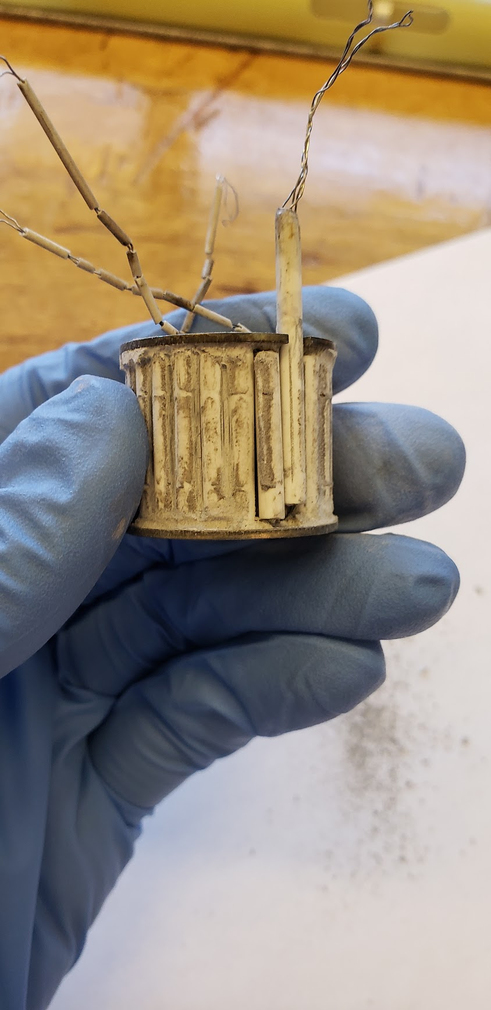

Figure 1: View of bobbin and ceramic tubes

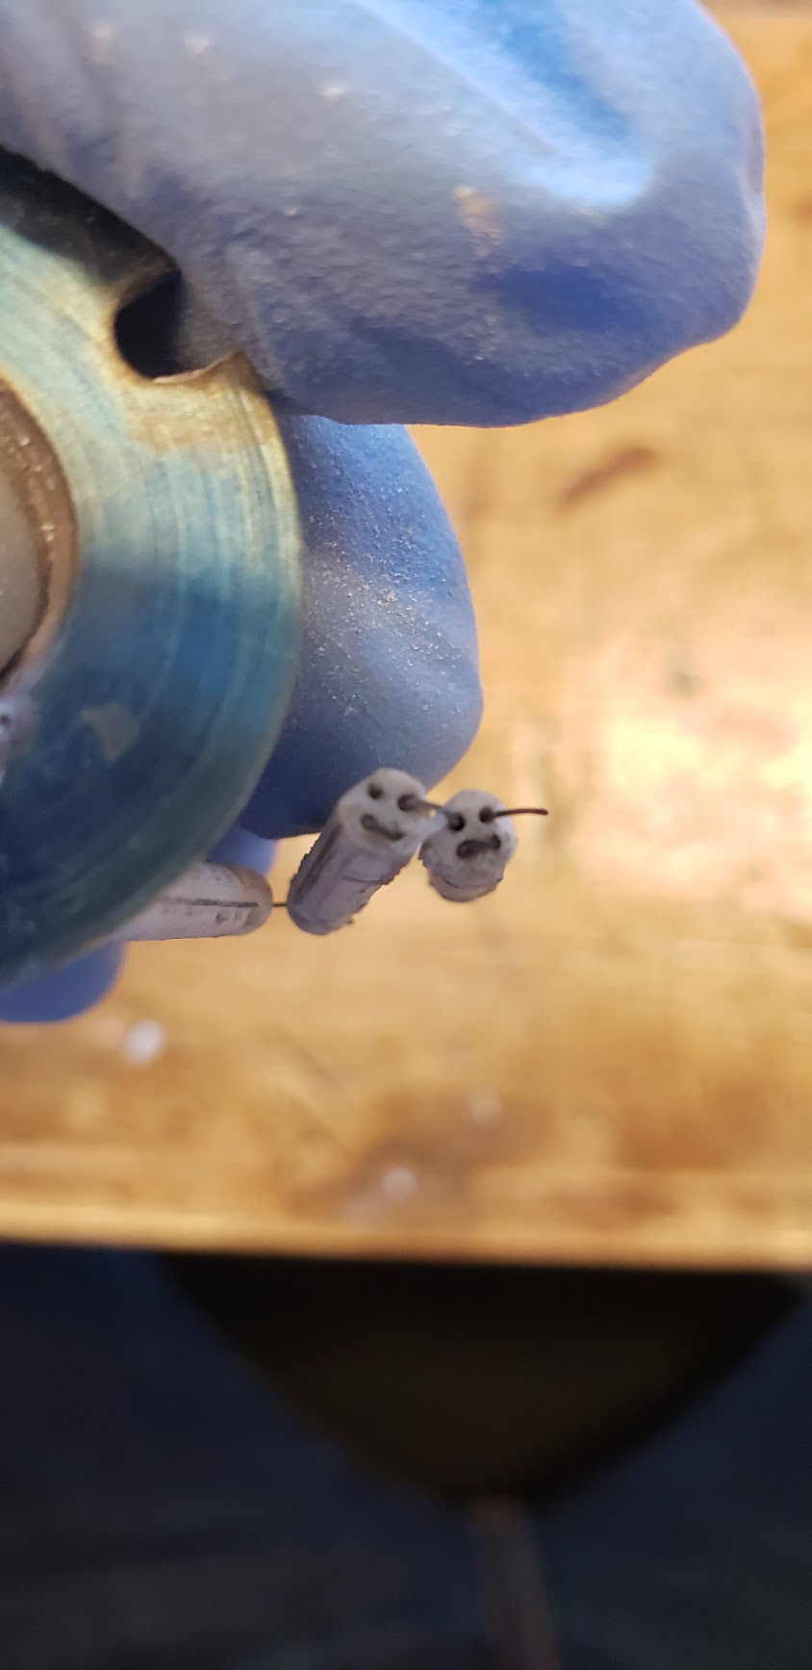

Figure 2: Top view of wire loops

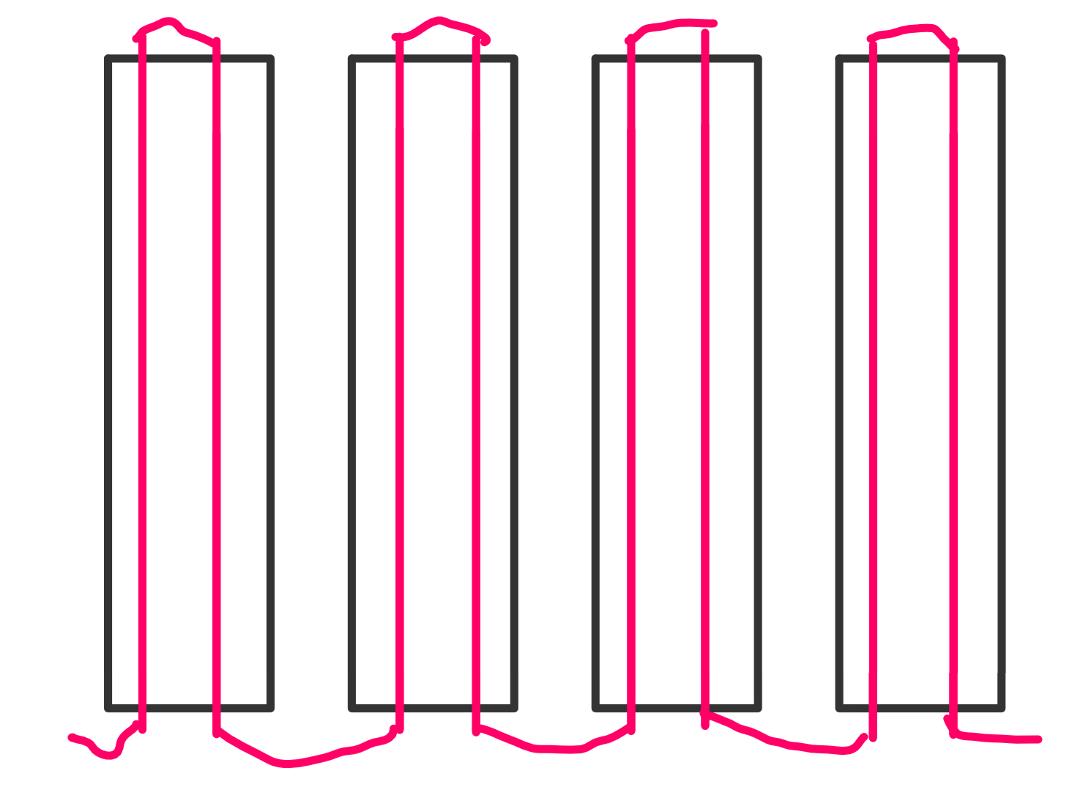

Figure 3: Diagram of wiring on a single loop

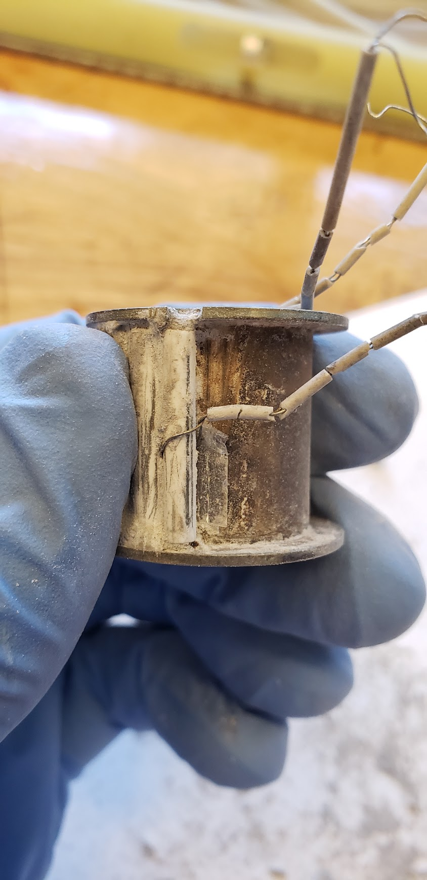

Figure 4: Thermocouple and Mica strip

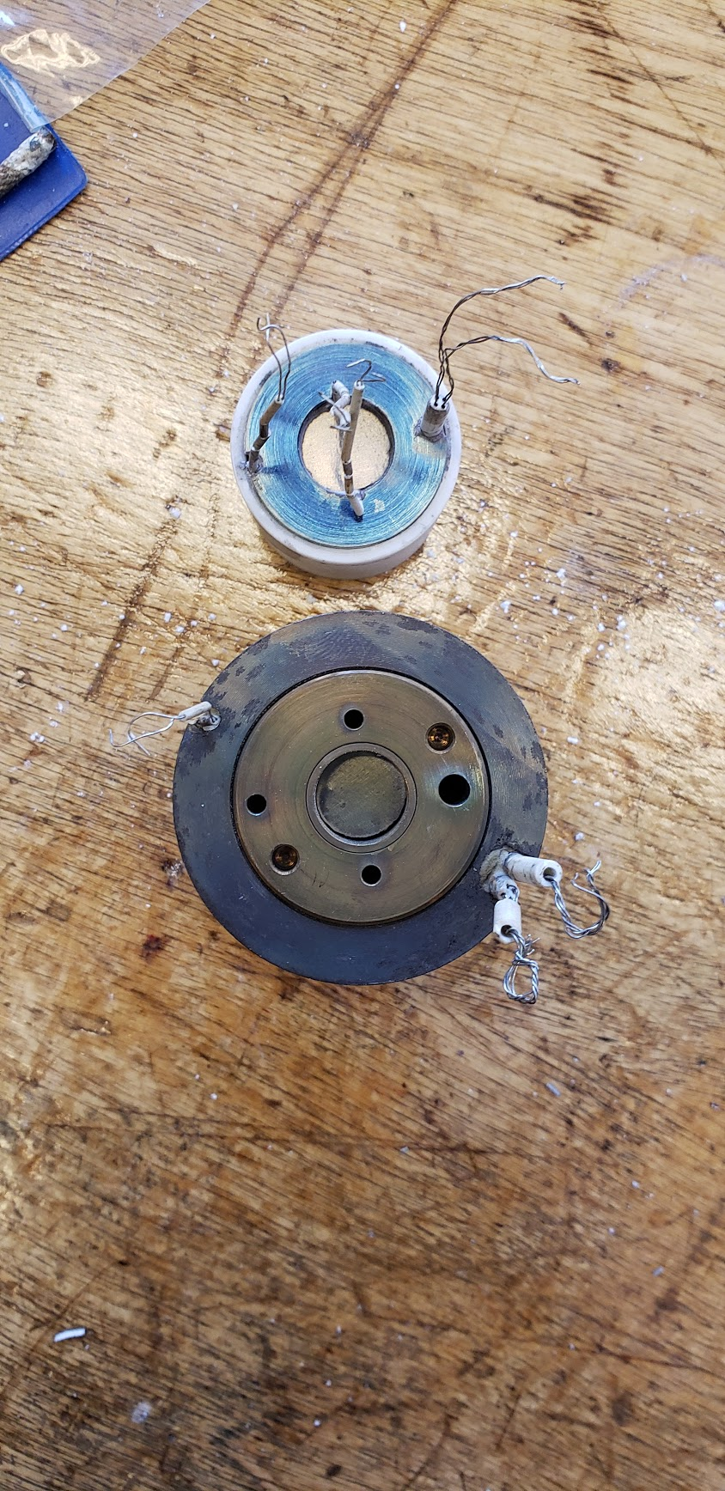

Figure 5: Outer Heater and Inner Heater

## Outer Oven

### Overview

The outer oven, like the inner heater, is a bobbin with ceramic tubes wrapped around them (Figure 6). The ceramic tubes, like the inner oven, are FRM-02018-X tubes ([OMEGA](https://omega.ca/pptst_eng/ORX_INSULATORS.html)). There are 39 33 mm tubes and 2 40 mm tubes. 11 6’’ ceramic tubes will be required for the outer oven.

The wire follows the same pattern as the inner heater: the last hole skipped on the loop that connects the tubes at the top, because the wires must enter the last tube from the bottom. Unlike the inner oven, there are 2 exit ceramic tubes, both 40 mm long, which allows the belt to be wrapped around when installing, and then tied into place during the cementing.

There is an additional wire put through the hole where the wires exit, and the adjacent unused hole (Figure 7). The wire ends that is put through the same hole as the loops is then cut where it exits the tube, resulting in 4 wires being twisted together (Figure 8).

A thermocouple is wrapped around the 20th ceramic tube, with a sheet of mica around it to prevent shorts. The thermocouple tubing is, like the inner heater, TRM-010364-X ([OMEGA](https://omega.ca/pptst_eng/ORX_INSULATORS.html)).

This is all to be cemented together in the same way as the inner heater: put cement on the inside and a sheet of mica where the thermocouple will be, wrap the belt around, tie it very tightly with wire. This stage is a bit more forgiving as it does not have to fit into a ceramic tube as with the inner heater, some expansion after tying can be tolerated.

The top of the outer oven can be removed with a tool in the container labelled ‘furnace parts’. Doing this with the inner heater installed will result in the destruction of all the thermocouples. There is a sheet of beryllium at the top, viewable in Figure 5.

There are 6 holes at the top and 6 holes at the bottom on the heaters side, placed evenly around the bobbin (Figure 9). There are used for suspending the oven in the shell that goes around this. It is advised to keep these cement free so that the ceramic tubes (FRM-164116-X or TRM-164116-X [OMEGA](https://omega.ca/pptst_eng/ORX_INSULATORS.html)) will fit.

### Pictures

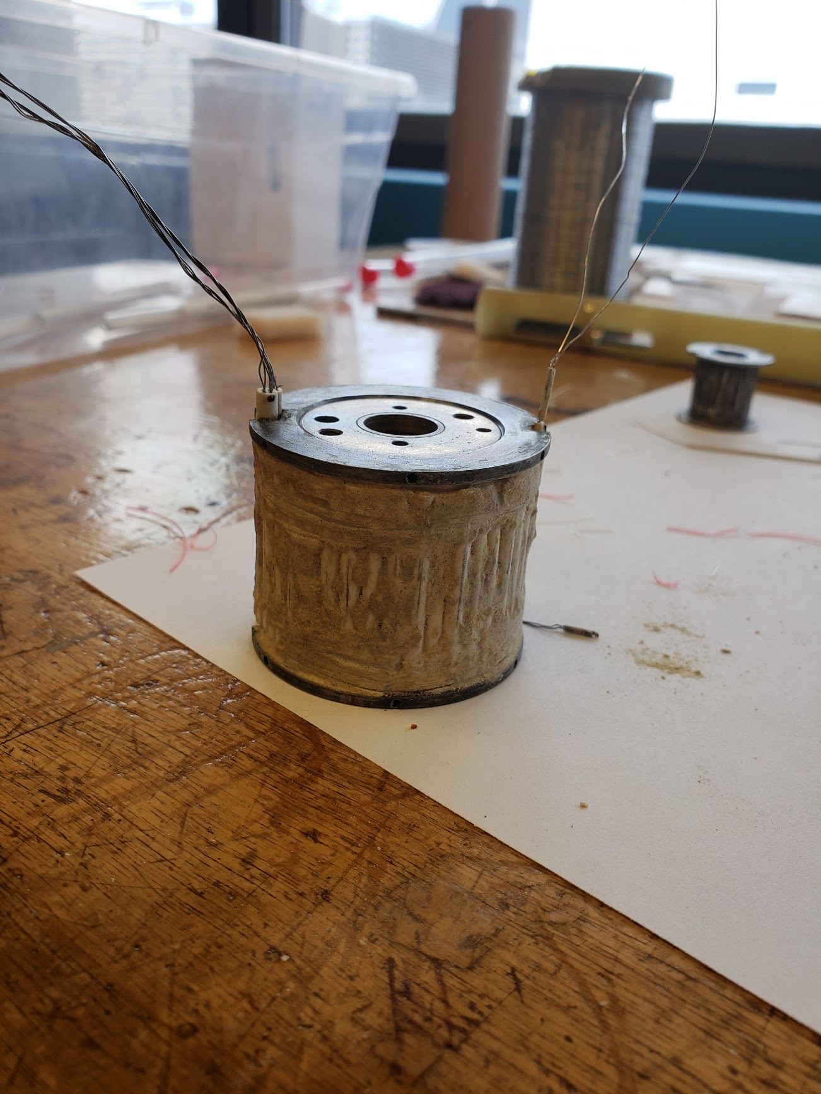

Figure 6: Outer Oven

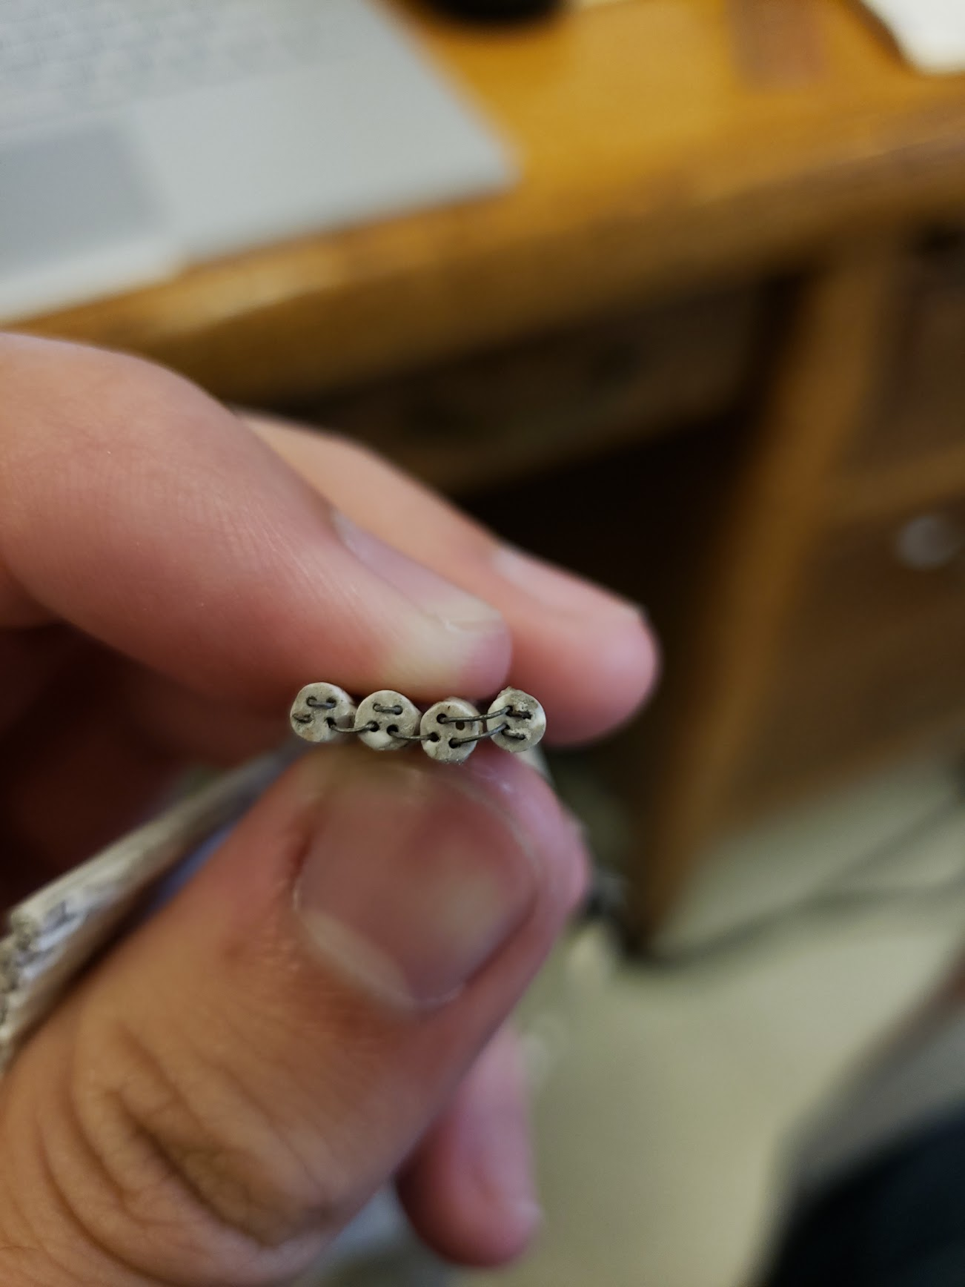

Figure 7 Ending of wire loop (rightmost wire is the last)

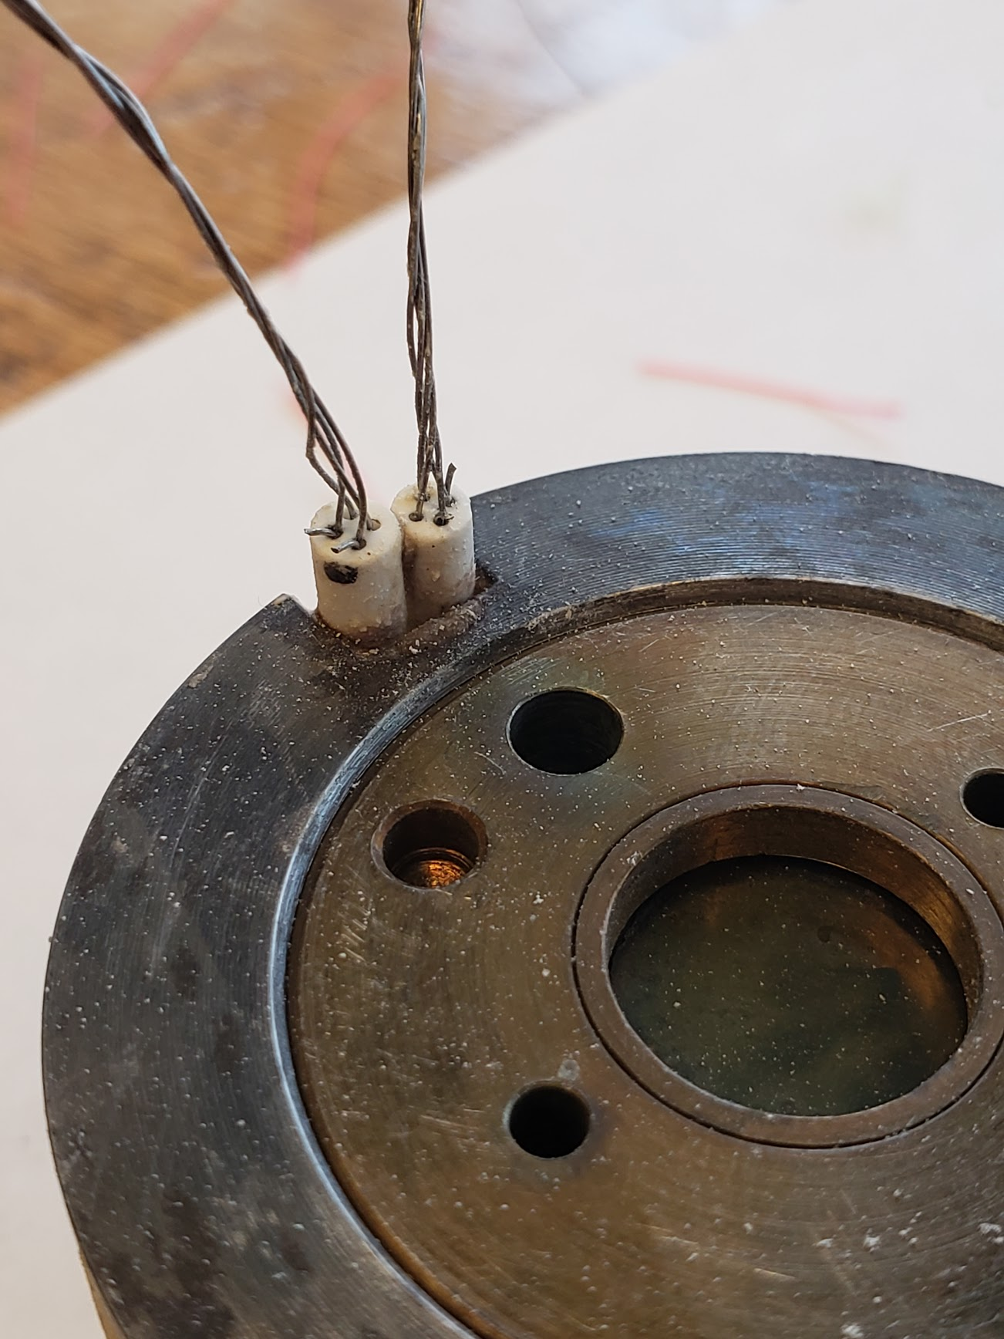

Figure 8: End of the loops

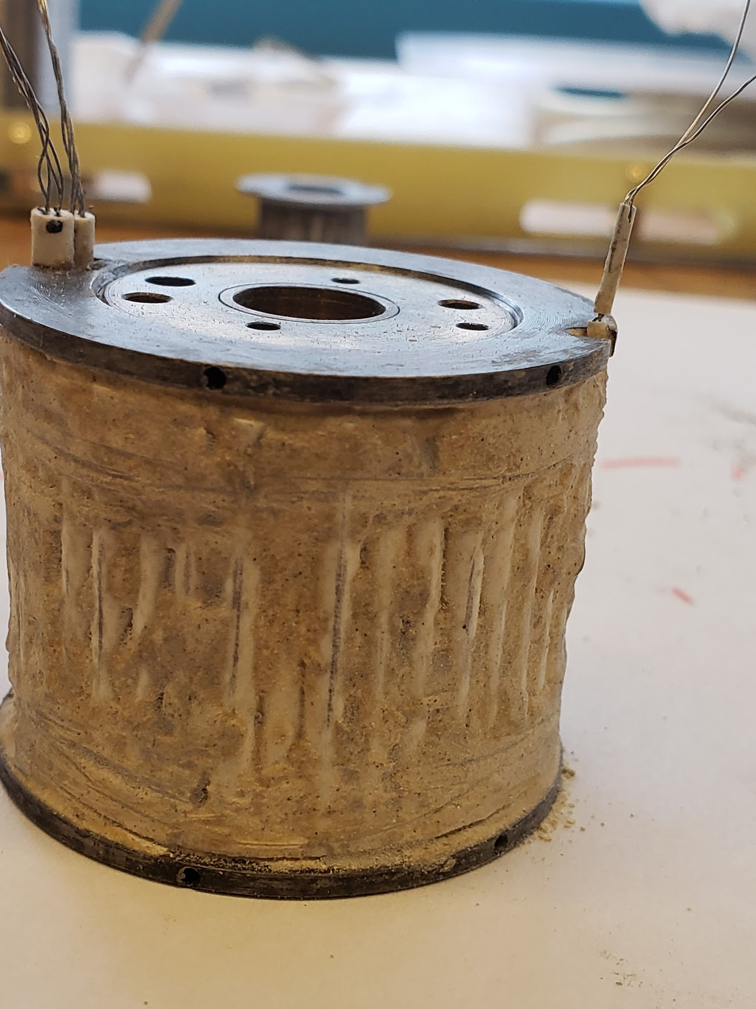

Figure 9: Mounting holes on the top and bottom of the outer heater

# Part List

|  |  |  |  |
| --- | --- | --- | --- |
| Part | Size | Quantity | Link |
| Ceramic Tubes for Inner Heater Loop:  FRM-02018-X | 22 20mm tubes  1 35 mm tubes | 4 6’’ tubes | <https://omega.ca/pptst_eng/ORX_INSULATORS.html> |
| Ceramic Tubes for Outer Heater Loop:  FRM-02018-X | 39 33mm tubes  2 40mm tubes | 11 6’’ tubes | <https://omega.ca/pptst_eng/ORX_INSULATORS.html> |
| Ceramic Tubes for Inner Heater Thermocouples  TRM-010364-X | 3 30mm tubes | 1 6’’ tube | <https://omega.ca/pptst_eng/ORX_INSULATORS.html> |
| Ceramic Tubes for Outer Heater Thermocouples  TRM-010364-X | 1 30mm tube | 1 6’’ tube | <https://omega.ca/pptst_eng/ORX_INSULATORS.html> |
| Ceramic Tubes for Mounting  FRM-164116-X or  TRM-164116-X |  |  | <https://omega.ca/pptst_eng/ORX_INSULATORS.html> |
| Thermocouple wire  TFAL-010-50 | N/A | 1 spool | <https://omega.ca/pptst_eng/TFIR_CH_CI_CC_CY_AL.html> |
| Thermocouple wire  TFCY-010-50 | N/A | 1 spool | <https://omega.ca/pptst_eng/TFIR_CH_CI_CC_CY_AL.html> |
| High Temperature Cement  OB-400 | N/A | 1 can (8 fluid oz.) | <https://omega.ca/pptst_eng/OB_OMEGABOND_AIR_SET.html> |

*part list does not include a safety padding

# Github

<https://github.com/RickyZiegahn/Oven-Temperature-Controller>